POST-LAB 2
Solutions & Dilutions
Directions:
TYPE the answers to the following questions and turn in ONE WEEK after lab session. You may handwrite answers to math questions but please use clear handwriting.

Questions:
- (4pts) Explain how to make each of the following solutions using the table below.
Question #1 | Grams Solute | Final Volume
100ml of 250mM (0.25M) MgCl₂
2 L of 100mM NaCl
100ml of 1% MgCl₂
10ml of 4% MgCl₂

- (2pts) Explain how to make each of the following solutions using the table below.
Question #2 | Volume Stock | Volume Water
100ml of 1x solution from 10x stock
1 L of 1x solution from 5x stock

- (2pts) 10x PBS stock is a commonly used buffer in Biology labs.
  - What do the abbreviated letters in “P.B.S.” mean?
  - Use Google to find a recipe for 10x PBS and write it here.

- (4pts) If you wanted to measure out the following volumes using micropipettes, which one would you use AND what would the dial read? Try to pipette the volume with only ONE step. For a few questions, you will need TWO steps. Remember that the lines at the bottom represent the next digit lower.
Volume | Micropipette to use | Setting
975l
7.5l
1.2mL
125l

- (4pts) You make a 10ml solution of 1M NaCl. For the following errors in your method, is the resulting solution at a lower or higher concentration than 1M?
Question #4 | Higher or Lower?
A- If some powder is left on the weigh paper (or weigh boat)…
B- If some of the powder does not fully dissolve in the water…
C- If you boiled the solution and some of the water evaporated…
D- If the meniscus is lower than the 10mL line of the cylinder…

- (6pts) You weigh 1.0 gram of protein and dissolve it in 1.0 mL of water to make a stock solution with a concentration of 1 g/mL.

6a. Using your 1g/mL stock solution (Hint: C₁), you wish to make 100mL of a 20 mg/mL solution. (Hint: V₂. and C₂) How do you make this working solution?
What is the DF for this dilution? (Hint: Review how to calculate DF in lab manual.)

6b. You also wish to make 20mL of a 0.01 mg/mL solution. (Hint: NEW V₂. and C₂) How do you make this working solution? Will you use your original 1 g/mL or do you need to serially dilute from your 20 mg/mL? (Hint: try both methods and see which one makes it easier to pipette.)
Which solution (1 g/mL OR 20 mg/mL) did you use to make 0.01 mg/mL? ________
Qu.# 6 | Volume Stock | Final Volume | Dilution Factor
6a.
6b.

- Your Excel data table for Serial Dilution lab: *
7a. (4pts) Include a clear and labeled table of your data. See below for expectations.
7b. (2pts) Calculate averages for each cuvette and include in your table.

- Your Excel data graph for Serial Dilution lab: **
8a. (6pts) Include a clear and labeled graph of your data. See below for expectations.
Do not graph two of your data points: your blank or your DF=1.
8b. (2pts) Include your trendline fit, equation, and r² for your line on your graph. Try different types of equations and choose the one with the highest r².

- (2pts) What is the definition of “r²“ (in terms of a trendline)? (Use your own words.) How do you know which is the best trendline for your data?

- (2pts) Define dependent and independent variables. (Use your own words.) Which one is usually on the x axis and which is on the y axis?
Variable | Axis (x or y?)
Dependent Variable
Independent Variable

* Expectations for MS Excel Tables
Title should be “Table 1:” followed by a description (do not use the word “data”).
Table should have line borders around each box.
Table should have clear labels for each row and column. Include units in parentheses. Tables should not have extra boxes or be too wide or narrow.
** Expectations for MS Excel Graphs
Title should be “Figure 1:” followed by a description (do not use the word “graph”) Graph should be “marked scatter” style.
Graph should have well labeled x and y axes. Include units in parentheses.
Graphs should be properly sized (not full-page or tiny)

LAB 3 Bradford Assay
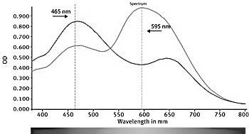

BRADFORD DYE SHIFT

No protein → maximum absorbance at 465nm
Protein → maximum absorbance at 595nm
http://www.pharmaceutical-int.com/article/bradford-protein-assay-evaluation-software.html

LAB 3
Bradford Assay
Laboratory Procedure

Introduction:
Today you will determine the concentration of an unknown protein sample, also shown as [Protein], using a standard curve of protein and Bradford dye.
Bradford reagent is Coomassie Brilliant Blue G-250 dye. It is cheap, sensitive, and specific for protein (does not bind to other macromolecules). This dye, being a blue color, absorbs light best at the wavelength of 470nm. When Coomassie dye binds to protein, the dye changes color and absorbs light best at 595nm. (See the cover sheet for this lab.)

LAB OUTLINE:
- Preparing the Protein Standards by Dilution
- Bradford Assay

You will begin your assay by creating protein standards. We will be using a cheap and commonly-used protein called Bovine Serum Albumin (BSA) to make our standards. The standards will be the following [Protein]: 5g/ml, 10g/ml, 20g/ml, and 30g/ml.

The, protein standards will be used to make a standard curve. Using this curve, we can calculate the concentration of protein in unknown samples. As long as our sample of unknown [Protein] lies within these standards, we will be able to estimate the concentration.

TYPICAL BRADFORD STANDARD CURVE
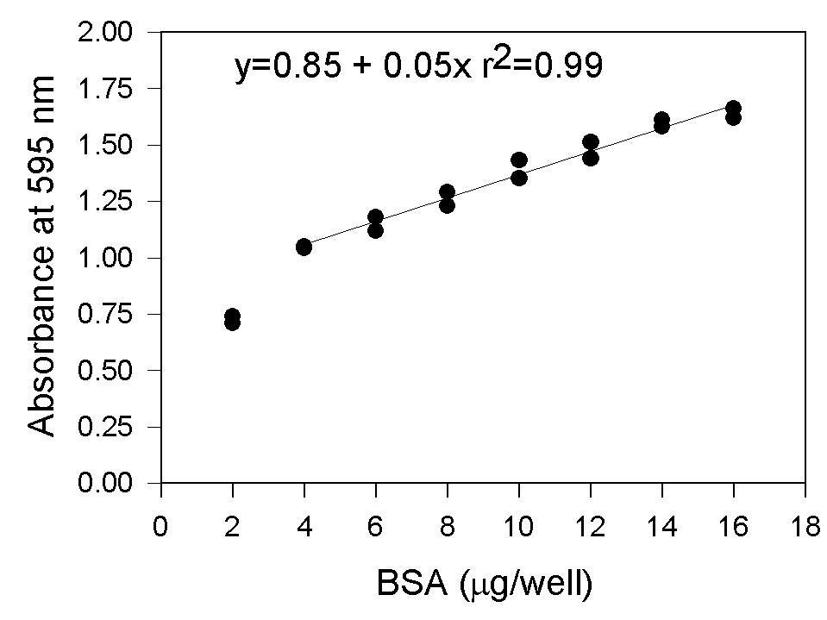

http://www.biocompare.com/images/bc/004/articleimages/1004%20SS%20Bradford.gif

LAB3-Prelab

PRE-LAB 3
Bradford Assay

Directions:
TYPE the answers to the following questions and turn in BEFORE lab begins. If pre-lab is not complete at the beginning of lab, the student will be unable to participate in the lab session.

Questions:
- (1pt) What is the difference between the IDENTITY of the protein and the
CONCENTRATION of the protein? For this lab, what is the identity of our protein? For this lab, what is the concentration (or concentrations) of our protein?
- (1pt) In this lab, what does the spectrophotometer measure? (Use your own words.)
- (4pts) If you wanted to measure out the following volumes using micropipettes, which one would you use AND what would the dial read?
Volume | Micropipette to use | Setting
725l
155l
1.8l
0.06mL

- (4pts) In this experiment, you will make Protein Standards using a Dilution scheme. Read through the directions in the lab and perform the required calculations. Copy your calculated answers into the lab protocol before you turn in your prelab.
4a. You will make 10ml of 2mg/ml (or 2000g /ml) of BSA.
How much will you weigh (in GRAMS) for 10mL of 2mg/ml? ____________
4b. Second, you will make 10ml of 100g/ml. (Hint: Use C₁V₁=C₂V₂)
How much 2000g /ml BSA will you add to make 10mL of 100g/ml? _____________
How much water will you add to this solution? ________________
4c. Next, you will use the 100g/ml stock solution to make 1ml each of 5g/ml, 10g/ml, 20g/ml and 30g/ml. (Hint: Use C₁V₁=C₂V₂)
[BSA] | Volume Stock | Volume Water | Total Volume
5 g /mL |            l of 100ug/ml | l H2O | 1000 l
10 g /mL | l of 100ug/ml | l H2O | 1000 l
20 g /mL | l of 100ug/ml | l H2O | 1000 l
30 ug/mL | l of 100ug/ml | l H2O | 1000 l

LAB3-Postlab

POST-LAB 3
Bradford Assay

Directions:
TYPE the answers to the following questions and turn in ONE WEEK after lab session.

Questions:
- (2pts) Describe the correlation between protein concentration and absorbance in your data.

- (5pts) What happens to the color of Bradford dye when it interacts with protein? Why?

- (5pts) Why do we need to make a standard curve for this experiment?

- (5pts) Include a MS Excel table of [Protein] and Absorbance. *

- (5pts) Estimate (from your data) the [Protein] of your unknown. Include the correct unit.

- (5pts) Include a graph of your [Protein] (x-axis) versus Absorbance (y-axis). **

- (5pts) Use MS Excel to find a trendline for your data. (This might not be linear. Use r² values to find the best fit.) Display this equation and the r² value on your graph

- (5pts) Using the trendline equation, calculate the concentration of protein in the Unknown sample. Include the proper unit for full credit.

- (3pts) Describe any errors in your technique. How could you improve upon your technique in order to get a better and more accurate standard curve graph?

* Expectations for MS Excel Tables
Title should be “Table 1:” followed by a description (do not use the word “data”).
Table should have line borders around each box.
Table should have clear labels for each row and column. Include units in parentheses. Tables should not have extra boxes or be too wide or narrow.
** Expectations for MS Excel Graphs
Title should be “Figure 1:” followed by a description (do not use the word “graph”) Graph should be “marked scatter” style.
Graph should have well labeled x and y axes. Include units.
Graphs should be properly sized (not full-page or tiny)

LAB 4 ENZYME KINETICS

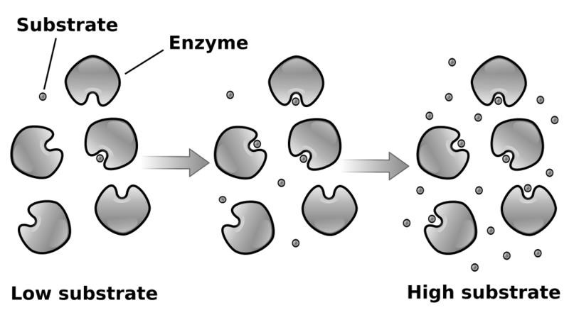

ENZYME
KINETIC
S

CONCEPTS

http://www.scie
ncegeek.net/Biology/review/U2Enzymes.htm

LAB 4
Enzyme Kinetics
Laboratory Procedure

Introduction:
Lactase is an enzyme that digests the sugar found in milk, lactose. Lactase is part of a family of enzymes called beta-galactosidases (or -gals). These enzymes hydrolyze the glycosidic bond of carbohydrates. Some humans lack a functional lactase enzyme and therefore cannot digest lactose properly. A commercially available pill containing the lactase enzyme allows lactose-intolerant individuals to digest milk.

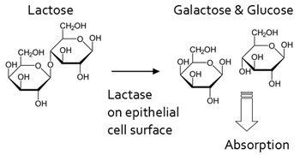

-gal enzymes hydrolyze their natural substrate (lactose) as well as other substrates with a -glycosidic bond. In our experiment, we will use the substrate ONPG (ortho-Nitrophenyl-βgalactoside). The ONPG substrate is broken to form a yellow ONP product. When we use this substrate, -gal activity can be seen using a spectrophotometer since activity of the enzyme changes the color of the solution to yellow.
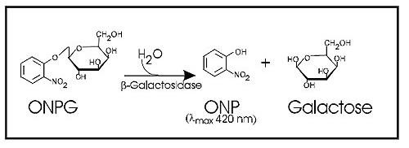

LAB OUTLINE:
- Making the Lactase Solution
- Making the ONPG Solution
- Quick Assay of Lactase Activity
- Lactase Assay with Vernier SpectroVis

Introduction (continued):
Enzymologists study enzymes to determine each enzyme’s characteristics. When enzymes are given low levels of substrate then enzyme activity is low, since time is required for enzyme to randomly bump into substrate. However, in high concentration of substrate, enzyme activity is high. In unlimited substrate, the enzymes are saturated and the enzyme’s rate is at its maximum. This level of activity is called the Vmax (maximum velocity).

Enzymes bind to substrate with weak, noncovalent bonds. The strength of these bonds determines how well the enzyme and substrate bind to each other. This characteristic is called the Km. The Km can be determined by finding the substrate concentration at ½ Vmax.

Enzyme activity is described by the Michaelis-Menten equation. You don’t need to worry about the details of this equation. You just need to understand the main idea of this equation: enzyme activity (v), Km, and Vmax are linked.

Michaelis-Menten: |  |  | v | = | Vmax [S]  Km + [S]
v = initial rate Km = substrate / enzyme binding Vmax = maximum enzyme rate [S] = substrate concentration

The simplest way to find the Km and Vmax is to determine the rate of reaction with different substrate concentrations. In other words, put varying amounts of substrate in reaction tubes. Here is a Michaelis-Menten graph. Note that the x-axis is the concentration of substrate.

MICHAELIS-MENTEN GRAPH
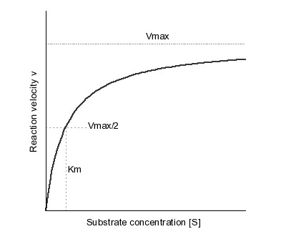

Another way to correlate substrate concentration with enzyme velocity is by the Lineweaver-Burk plot. The terms in the Michaelis-Menten equation are rearranged to make a linear equation (y=mx+b). Again, just understand the main idea, not the details.

Linear Equation: | y | = | m x | + |  | b
Lineweaver-Burk: | 1 | = | (Km) (1) | + |  | 1
 | v |  | Vmax [S] |  |  | Vmax

y = 1 / v x = 1 / [S]
m = slope = Km / Vmax b = y-intercept = 1 / Vmax

Using this equation, we graph 1/[S] on the x-axis versus 1/v on the y-axis. The slope of the resulting line (“m”) is Km/Vmax and the y-intercept (“b”) is 1/Vmax. Again, look at the Lineweaver equation above to see why we need to take the reciprocal of our data to get a linear line.

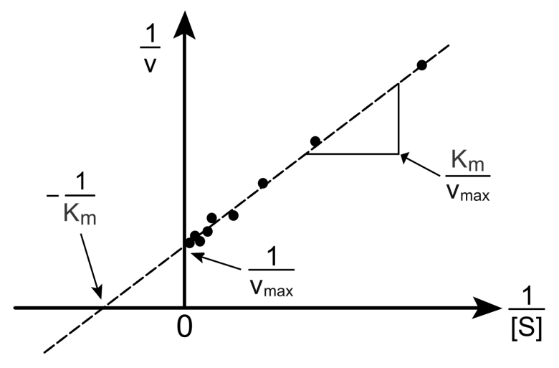

LINEWEAVER
-
BURK

GRAPH

Today, you will run an enzyme assay with lactase using varying amounts of the ONPG substrate. You will then calculate your enzyme velocity at different concentrations of substrate. From this, you will graph both a Michaelis-Menten plot as well as a Lineweaver-Burk plot. You can use the Lineweaver-Burk to calculate the Vmax and Km of this enzyme.

ONLY ONE LAB GROUP WILL DO PART A.

A- Making the Lactase Solution from Lactaid Tablet
- One group will cut the lactase pill in half with a razor blade.
- Place half Lactaid pill in a mortar. Note that the Lactaid tablets we use are at 9,000 units/pill.
- Using the pestle, crush the pill thoroughly.
- Carefully transfer the powder into a 100mL beaker.
- Add _____ mL 0.1M Phosphate buffer to lactase powder to make 50units/mL (PRELAB) 6. The Lactaid enzyme (lactase) will dissolve. But most of the pill binder will not. Let the pill binder powder settle to the bottom of the beaker. (Pill binder is the extra material in pills that holds them together.)
7. Make aliquots in small beakers for other lab groups to use.

B- Making the ONPG Substrate Solution
- The ONP has already been dissolved to a concentration of 20mM.
- Label a glass test tube with “ONPG”.
- Dilute the 20mM stock with water. You will make 6mL of a 1:2 dilution. (PRELAB)
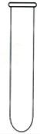

C- Quick Trial Assay of Lactase Activity
- Turn on Spec20 and set wavelength to 420nm. Allow Spec20 to warm up for 10 minutes.
- Take out one glass cuvette. Add 1.25mL water and 0.25mL 0.1M Phosphate Buffer.
- Add 0.25mL of your ONPG dilution. Vortex to mix thoroughly.
DO NOT ADD LACTASE YET!!!

- Calibrate Spec20 using this cuvette. Absorbance should be zero.

- GET GROUP READY FOR TIMED ASSAY. AT SAME TIME:
  - Start timer.
  - Add 0.25mL of Lactase. Immediately close top of Spec20.
  - Every 15 seconds, get an approximate Absorbance of your cuvette. Record below.
  - Once you finish, observe the cuvette. What color is the liquid? WHY?

Cuvette Contents:
Cuvette | Water | 0.1M Buffer | ONPG | Lactase
TRIAL | 1.25mL | 0.25mL | 0.25mL | 0.25mL

Data Table:
Reaction | 0 sec | 15 sec | 30 sec | 45 sec | 60 sec
TRIAL #1
TRIAL #2*
* Do a second trial, if needed.
WHAT COLOR IS THE CUVETTE AT THE START OF THE REACTION? _________
WHAT COLOR IS THE CUVETTE AT THE END OF THE REACTION? ___________
C- Lactase Assay with SpectraVis
- Turn on the Computer (back left button) and plug in keyboard and Spectrovis to USB ports (back right). Open LoggerPro.

- To set up SpectraVis for Lactase Assay:
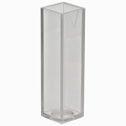
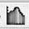
Setting up a Time-Based Assay

Click on the Data Collection Button.
Set type to “Time Based” with Duration of 60 sec for 15 sec/sample (NOT 15 samples/sec).
Setting the Wavelength and Calibrating Click on the Configure Spectrophotometer Button.
Select 420nm wavelength of light.
Making your Blank cuvette for Calibration Pipette 2mL of distilled water into a cuvette.
Kimwipe cuvette sides then place cuvette into SpectraVis with stripes front and back. In Experiment menu, select “Calibrate”. Click buttons as needed.

- To prepare experiment cuvettes:
Get 7 clean small square plastic cuvettes. Label them with their [ONPG].
Using the table below, add the water, buffer, and ONPG to each cuvette.
DO NOT ADD LACTASE YET. If you do, you will have to start over.

CONTENTS OF REACTION CUVETTES: (Calculations in PreLab)
[ONPG] | Water | Buffer | ONPG | Lactase
0mM | 1.5mL | 0.25mL | None | 0.25mL
 | 1.25mL | 0.25mL | 0.25mL | 0.25mL
 | 1.0mL | 0.25mL | 0.5mL | 0.25mL
 | 0.75mL | 0.25mL | 0.75mL | 0.25mL
5mM *** | 0.5mL | 0.25mL | 1.0mL | 0.25mL
 | 0.25mL | 0.25mL | 1.25mL | 0.25mL
 | None | 0.25mL | 1.5mL | 0.25mL
*** HINT: To calculate [ONPG], cuvette #5 contains 1.0mL ONPG in a total of 2.0mL. (This is the same as a 1:2 dilution.) Therefore we divide the concentration of ONPG by 2 to get 5mM.

- To perform Lactase Assay with first cuvette (“0mM”):
Clean cuvette with Kimwipe.
Place cuvette into SpectroVis with stripes in front in back.
GET GROUP READY FOR TIMED ASSAY. AT THE SAME TIME:
  - Press Record (Green Triangle button).
  - Add 0.25mL of Lactase to cuvette. Use pipette to quickly mix liquid.
WAIT 60 SECONDS! After the assay is complete:
  - In Experiment menu, select “Store Latest Run” THIS STEP IS NECESSARY! * Record data on the data table below.
- Repeat Step 7 for all of your cuvettes. Record the data below.
DATA TABLE: Lactase Assay with A₆₀₀ of Assay Tubes over 60 seconds
[ONPG] * | 0mM |  |  |  | 5mM
 |  | A₄₂₀
Time(sec)
0
15
30
45
60
* Fill in ONPG concentrations using your prelab.

Your data should be near linear for the first 30 seconds. After about 60 seconds, your data may plateau. (The SpectraVis is unable to read well when it gets above 1.5 Absorbance)

Enzyme Velocity = (Absorbance at time 60 seconds) − (Absorbance at time 0 seconds)

Michaelis-Menten Data:
ONPG concentration (mM) | Enzyme Velocity (Change from 0 to 60 sec.)
0
5

Lineweaver-Burk Data:
1 / [ONPG] | 1/ Velocity
Do not graph this data point | Do not graph this data point
1/5 = 0.2

CALCULATIONS FOR POSTLAB:

Lineweaver-Burk Linear Equation: _____________________________________ (y=mx+b)

Use your equation to calculate Vmax and Km.

Vmax = 1/b = ___________

Km = (m)(Vmax) = ___________

PRE-LAB 4
Enzyme Kinetics

Directions:
TYPE the answers to the following questions and turn in BEFORE lab begins. If pre-lab is not complete at the beginning of lab, the student will be unable to participate in the lab session.

Questions:
For questions #1 through #4, please put your answer on the table below.
- (1pt) In this lab, we will make lactase solution that is 50 units of lactase per mL phosphate buffer. The Lactaid pill’s box label states that each pill contains 9,000 units. We will be using a half pill. How many mL of phosphate buffer do you need to add to a half pill?

- (1pt) In this lab, we will be performing a 1:2 dilution of 20mM ONPG. You will need 6mL. You will add _____mL of 20mM ONPG and _______mL of water to your test tube.

- (1pt) After your 1:2 dilution of ONPG, what is the concentration of ONPG?
- (1pt) For each tube, how long will the enzyme be allowed to react with substrate?
Question | Answer
1. volume phosphate buffer? | mL
2. mL of ONPG |                  mL ONPG + mL water
3. concentration of ONPG? | mM
4. the spectrovis will record how many data points for each assay? | Data Points

- (2pts) What is the final ONPG concentration (in mM) of each of the Reaction tubes?
mM of ONPG in Reaction tube
= 0mL of ONPG in a total volume of 2mL = 0 (10mM) = 0mM
= 0.25 mL of ONPG in a total volume of 2mL = (0.25 *10mM)/ 2 = 1.25mM
= ___ mL of ONPG in a total volume of 2mL = (___ *10mM)/ 2 = ___ mM
= 1.0mL of ONPG in a total volume of 2mL = ½ (10mM) = 5mM
***Hint: Use the table on p46 to figure this out. ***
- (2pts) If the normal substrate for lactase is lactose sugar, why do we use ONPG?
- (2pts) In this assay, will we be varying enzyme concentration OR substrate concentration in the different assay tubes?

LAB4-Prelab

POST-LAB 4
Enzyme Kinetics
Directions:
TYPE the answers to the following questions and turn in ONE WEEK after lab session.

Questions:
- (2pts) Create a Table of your data of Time and Absorbance for all concentrations of ONPG.*

- (5pts) Create a Graph of time (x-axis) versus absorbance (y-axis) for all of your concentrations of ONPG. Include a legend (the concentrations of ONPG). **

- (2pts) Create Table 2 of your Michaelis- Menten data. *

- (5pts) Create a Graph (Figure 2) of the Michaelis-Menten data. No trendline needed. **

- (2pts) Draw (with pen or pencil) on your Michaelis-Menten graph your Vmax, ½ Vmax and Km. (Hint: see the example M-M graph.) Make a table with your estimates for Vmax, ½ Vmax and Km.

- (2pts) Create Table 3 of your Lineweaver-Burke data. *

- (5pts) Create a Graph (Figure 3) of the Lineweaver-Burke data. **

- (2pts) On your Lineweaver-Burke graph, use MS Excel to add a best-fit linear line. Show the linear equation of the graph as well as the r² value.

- (5pts) Using your Lineweaver-Burke linear equation, solve for the Vmax and Km of lactase.
Include the units for these numbers! Add your calculated values to your table from Question 5. Are your calculated values similar to your estimates?

- (5pts) Lactase’s preferred substrate is lactose, not ONPG. Is the Km for lactose to higher or lower than the Km for ONPG. Why?
- (5pts) Why do enzymes have a Vmax (maximum velocity)?
* Expectations for MS Excel Tables
Title should be “Table 1:” followed by a description (do not use the word “data”).
Table should have line borders around each box.
Table should have clear labels for each row and column. Include units in parentheses. Tables should not have extra boxes or be too wide or narrow.
** Expectations for MS Excel Graphs
Title should be “Figure 1:” followed by a description (do not use the word “graph”) Graph should be “marked scatter” style.
Graph should have well labeled x and y axes. Include units in parentheses.
Graphs should be properly sized (not full-page or tiny)
48

LAB 5 SDS PAGE

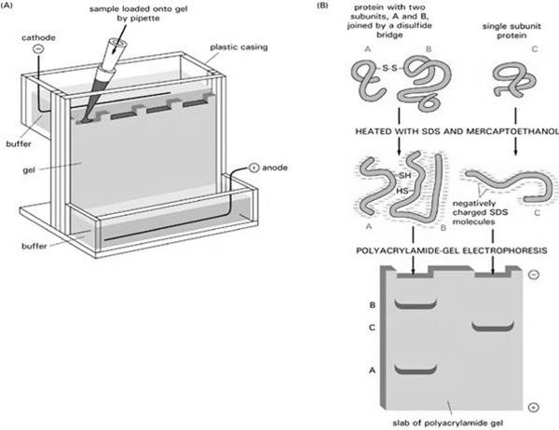

SDS PAGE CONCEPTS

http://en.wikipedia.org/wiki/Polyacrylamide_gel_electrophoresis

LAB 5
SDS PAGE

Laboratory Procedure

Introduction:
Today you will learn how to run SDS PAGE, or a protein gel. This technique is used by biologists to separate proteins according to their size (length of polypeptide chain and molecular weight). We will be using this technique to determine the size of an unknown protein.
Acrylamide is a dangerous substance which acts as a neurotoxin and a carcinogen.
Acrylamide should be handled carefully wearing gloves AT ALL TIMES. DO NOT TOUCH YOUR GEL WITH YOUR BARE HANDS!!! And please wash your bench top and hands
after this lab. We could pour our own gels (and many labs do pour their own). But for convenience, we will use pre-poured gels bought from a company.
We will place the acrylamide gel into the running chamber or gel box. The gel will sit in a box that contains running buffer. Running buffer is the buffer that will surround the gel during the electrophoresis. It will keep the gel from drying out, and carry the current. We will prepare and load our protein samples into the wells, a separate well for each sample. And then we will apply a current through the box to cause the proteins to move or migrate across the gel.
Two different unknown proteins (unknown #1 and unknown #2) will be run on the gel, and you will need to determine the molecular weight of each. Generally, samples are made by first determining the amount of protein in a sample then diluting the sample to load between 5-15
g (micrograms) for each 10l. The samples are mixed with 10l of 2x sample buffer. Sample buffer contains a dye and compounds that further denature the proteins (beta-mercaptoethanol).
The proteins on the gel are not visible (except for the ladder which is prestained). We will use Coomassie Blue dye to stain the gel. This stain will stick to the protein and the gel itself. When we wash away the stain with Destain solution, the blue color will remain on the protein bands but wash off the gel. This will allow us to see clear bands where protein is located. The ladder standards are used to determine the molecular weight of unknown proteins in kiloDaltons (kDa). However, this procedure does not identify the protein. Hundreds of different proteins are the same size! (Imagine if you tried to identify a person simply by knowing his height!) Knowing the size of a protein is a useful first step in learning what a protein is and what it does in a cell.

LAB OUTLINE:
- Preparing the Protein Samples
- Setting up a SDS Gel
- Loading the Gel
- Preparing Chloroplast Isolation Buffer (for next week’s lab)
- Staining and Destaining the Gel G- Analyzing the gel
http://www.bio-rad.com
A. Preparing the Protein Samples
- Get two eppendorf tubes and label the tops with “A” and “B”.
- Add 50l of one unknown to one eppendorf A and 50l of another unknown to eppendorf B.
UNKNOWN A = _________________ UNKNOWN B = _________________
- Add 23l of Invitrogen sample buffer to BOTH eppendorf tubes.
- Put both tubes in the heat block for 2 minutes at 100 degrees.
- Quick spin the tubes in the small centrifuges.

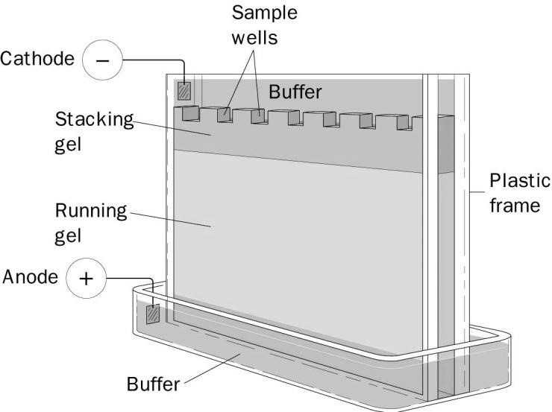
B. Preparing the SDS Gel (We will share gels on 1st bench) 1. Put on gloves.
http://www.bio
-
rad.com

- Make 400mL of 1x Running Buffer using 20x stock.
- Add some 1x Running buffer to the bottom of the gel box.
- Take gel out of bag and remove the white tape and comb.
- Place the gel in the chamber with wells facing you.
- Rinse wells 3x with running buffer using disposable pipette
- Add running buffer to front until it fills side chamber.
- Raise gel slightly for easier loading.
C. Loading the Gel
- Practice loading sample buffer into Lanes 1 and 2. Loaded lanes will be characterized by a light blue color rectangle (the more protein is loaded, the more obvious the color). If the sample doesn’t go into the lane then load it again.
- Next, load the other lanes as shown in this table.
Lane | Volume | Material
1 and 2 | Up to 20l | Sample buffer practice
3 | - | Blank
4 | 15l | Ladder *
5 | 5l | Unknown A
6 | 15l | Unknown A
7 | 15l | Ladder *
8 | 5l | Unknown B
9 | 15l | Unknown B
* We use the Invitrogen Prestained Protein Standards

- Carefully open the clamp, lower gel, then close clamp.
- Place the lid on the gel box then connect to power source.
- Run gel at 200V for 22 minutes.

D. Staining the Gel
- Turn off the gel after 22 minutes.
- Open the plastic plates by inserting metal spatula in the sides and twisting. Then gently let the gel fall off the plastic plates into a container of Coomassie stain. Wait one week.

E. Destaining the Gel (during second week of lab) 1. Pour off Coomassie stain into the designated container.
- Wash gel carefully with water to remove excess stain.
- Add Destain solution. Gently rock gel for 30 to 90 minutes.

F. Analyzing the Gel
- Pour destain into waste container. Add approximately 200mL of water to gel box. Gel may curl up for a few minutes but will eventually become flat again.
- Place plastic wrap on the surface of the light box. Carefully transfer your gel to the plastic wrap using wet gloves. Take a photograph of your gel for your records and lab report.
- Completely cover your gel with a layer of plastic wrap.
- Measure in mm (not cm) the distance travelled (or “migration distance”) for each protein in your ladder. Measure from the bottom of the well to each band.

Protein Ladder (for trendline graph):
Protein MW  (in kiloDaltons) | Log of MW  (for y-axis) | Migration Distance (mm) (for x-axis)
 | 2.26
 | 2.11
 | 2.00

Unknown Protein A
Distance Travelled (mm) | Estimated Protein size (kD)
Unknown Protein B
Distance Travelled (mm) | Estimated Protein size (kD)

G. Graphing the Data:
- Graph the LADDER data for Migration distance in mm (x-axis) versus Log of Molecular
Weight (y-axis). (Online, you may see graphs with “Rf” in the x-axis. We didn’t calculate the “Rf” in our protocol.)
- Create a trendline then use the equation to determine the LogMW your unknown protein bands.
- Using the LogMW of each unknown band, solve for the MW of each unknown band. Compare this to your estimates to see that the number is as expected.
- For protein gels, we do NOT add protein band sizes together. Each protein is it’s own protein, not part of a larger protein. (For DNA gels, band sizes are summed.)

My sincere thanks to Honors student Nhi Van for her insight and editing of this lab.

H. Preparing Chloroplast Isolation Buffer (for Hill Reaction Labs)
***During this lab, please make the buffer (described here) to use during the next lab. This part should NOT be included in your SDS PAGE Lab Report. ***

Procedure:
- Calculate how many grams of the following you need to make 125ml of:
0.35M NaCl (MW=58.44 g/mol) ________ grams
0.02M Tris Buffer (MW=121 g/mol) ________ grams
- Weigh out the NaCl and Tris and pour them into beaker.
- Add water up to about 100ml ONLY. Mix until powder is dissolved.
- Place the pH probe in the solution and add drops of HCl until the pH is 7.5. Add the
HCl SLOWLY. (Remember how titrations work in Chemistry lab?)
- Pour the material into a graduated cylinder, then add water up to exactly 125ml.
- Pour the buffer into your glass bottle. Label the bottle (as shown below)
- Put your bottle with the other bottles so that it will be stored in the refrigerator.

LABEL YOUR BOTTLE WITH:
  - Chloroplast Isolation Buffer, pH 7.5
  - today’s date
  - your group’s name or initials of each group member
  - ON THE GLASS- the meniscus on the bottle –125mL

LAB5-Prelab

PRE-LAB 5
SDS PAGE

Directions:
TYPE the answers to the following questions and turn in BEFORE lab begins. If pre-lab is not complete at the beginning of lab, the student will be unable to participate in the lab session.

Questions:
- (1pt) What does each of the letters in SDS PAGE stand for?

- (2pts) Why is SDS added to the protein and the gel? What are the TWO ROLES of SDS in the procedure? USE YOUR OWN WORDS.

- (1pt) What can you learn about a protein by running it on a gel?

- (1pt) What is actually in the protein ladder tube? How does the company make ladder? USE
YOUR OWN WORDS.

- (1pt) We want to make 1 Liter of 1x running buffer from the 10x stock. You will add ____ mL of 10x stock to _____mL water.

- (2pts) In this experiment, we will denature the proteins before we load them on the gel. What are the TWO ways by which we will denature the proteins in our experiment?

- (2pts) WHY do we need to denature the proteins before loading them on the gel? Use YOUR
OWN WORDS.

56
LAB5-Postlab

“Mini” POST-LAB 5

SDS PAGE

Directions:
TYPE the answers to the following questions and turn in ONE WEEK after lab session. Since you have a formal lab report for this lab, this MINI postlab will only count for 10 points.

Questions:
- (4pts) In this picture of an SDS PAGE (see below):
Question | Answer
a. Ladder and antibody samples have been loaded into different _______ on the gel.
b. The range (smallest to largest size) of the ladder is:
c. The approximate size (in kDa) of “Heavy Chain” is:
d. The approximate size (in kDa) of “Light Chain” is:

SDS PAGE of Antibody Proteins (“Heavy Chain” and “Light Chain” of Antibody proteins) with Ladder (kDa)
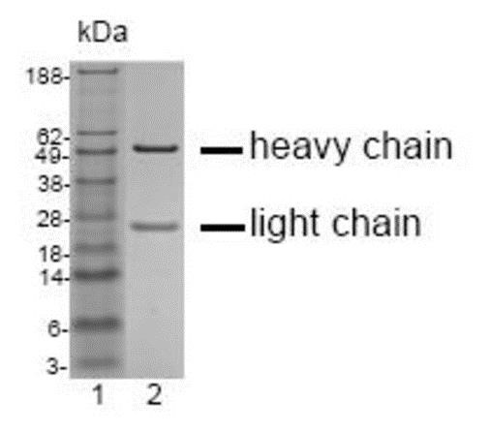

- (2pts) This gel has approximately 10g of protein in each lane.
  - What would this gel look like if you loaded 1g of protein in each lane?
  - What would this gel look like if you loaded 100g of protein in each lane?
- (2pts) This gel was run for 22 minutes.
  - What would this gel look like if we only ran it for 6 minutes?
  - What would this gel look like if we ran it for 2 hours?

- (2pts) How is the protein ladder similar in function to the Protein Standards that we used in the Bradford Assay?

LAB5-Report
SDS PAGE LAB REPORT
Description of Laboratory Work:
During this week, you will to determine the estimated molecular weights (M.W. in kiloDaltons or kDa) of unknown proteins by SDS PAGE. Each student must write his/her own lab report. In this assignment, the student will demonstrate his/her understanding of the SDS PAGE technique. The student will analyze his/her data to formulate a conclusion about the M.W.s of the unknowns.

Due Date: See Syllabus. Late lab reports will have 20% taken off of the grade. Reports more than a week late will receive a zero on the assignment.

Format:
Three to six pages long (not including figures, or coversheet)
Use lab report format (follow instructions on last page of handout closely) Typed double-spaced with reasonable margins
As with any writing assignment, do NOT plagiarize. Use your own words.

Grading:
15 points | Lab Formatting: Report follows correct lab report formatting. (See the attached sheet on lab report format.) All the information is in the correct section. References have been properly cited.
15 points | Grammar and Spelling: Spelling is correct throughout report. Grammar is excellent and wording should be clear and concise. Writing style should be scientific not conversational. PROOFREAD!!!
10 points | Title and Abstract: Includes a clear descriptive title. The abstract is an approximately 100 word summary of report. What did you do? Why did you do it? What did you find out from your work?
10 points | Introduction: Section includes the following content:  What is SDS PAGE? Why do biologists perform SDS PAGE? How does the technique work? In what context is SDS PAGE used?
10 points | Methods: Section includes a clear, chronological description of your laboratory work. Use paragraph format. Do not include results or discussion. Do not include the chloroplast buffer in this report.
10 points | Results: Professionally presents all data and a graph of your ladder. Include a short text describing the results. Do NOT state conclusions or speculation. All tables and figures should be professional quality.
15 points | Analysis: Discussion is a clear and correct analysis of your results. What did we learn about the unknown proteins? What are the sizes in kiloDaltons? How do you know? Were any errors made in your technique?
15 points | Interpretation: Approximately how many amino acids are in the unknown protein? Approximately how many nucleotides are in the mRNA transcript for this protein? Can you conclude anything about the size of the gene?

58
LAB5-Report

Some Basic Advice on Laboratory Report Formatting

General style:
Strive for logic and precision and avoid ambiguity.
Keep your writing formal. Use proper scientific wording.
Use the past tense and be consistent within the report.
Italicize all scientific names (genus and species); the first letter of the Genus should be capitalized.
Write numbers as numerals when greater than ten (i.e. 156).
Have a neutral person review and critique your report before submission.

Format: The typical lab report includes: title, abstract, introduction, materials and methods, results, discussion, references and literature cited.

Title: Reflect the factual content with less than ten words in a straightforward manner.

Abstract: Summarize in a concise paragraph the purpose of the report, data presented, and major conclusions (such as size of your two unknown proteins) in about 100 words.

Introduction:
- Written in paragraph form.
- Define the subject of the report: "Why was this study performed?”
- Provide background information: “Why is it useful to identify the size of unknown proteins?”, “How does SDS PAGE work?”, “When is SDS PAGE used?”

Methods:
- Describe chronologically what you did in the lab.
- You do not need to list your materials.
- Provide enough detail for the reader to understand the experiment without overwhelming him/her.

Results:
- Concentrate on general trends and differences and not on trivial details.
- Summarize the data from the experiments without discussing their implications (conclusions) - Organize data into tables, figures, graphs, photographs, etc.
- Make tables and figures look clear and professional. Clearly label axes and legends.
- Title and number all figures and tables.

Discussion:
- Interpret the data; do not restate the results.
- Explain the logic that allows you to conclude the size of your unknown proteins.
- Speculate as necessary, but identify it as speculation when you do so.
- Include suggestions for improving your techniques or design. Discuss any errors.
- Estimate the number of amino acids in the protein, and the number of nucleotides in the transcript.

References & literature cited:
- Alphabetize by last name of the author
- Follow the APA format for citations of references. For APA guidelines see www.library.cornell.edu/newhelp/res_strategy/citing/apa.html#apa

This information was adapted from http://www.studygs.net/labreports.htm; which had been adapted from Biological Investigations, 5th ed. By Warren D. Dolphin 1999, published by McGraw-Hill."

LAB 6
HILL REACTION
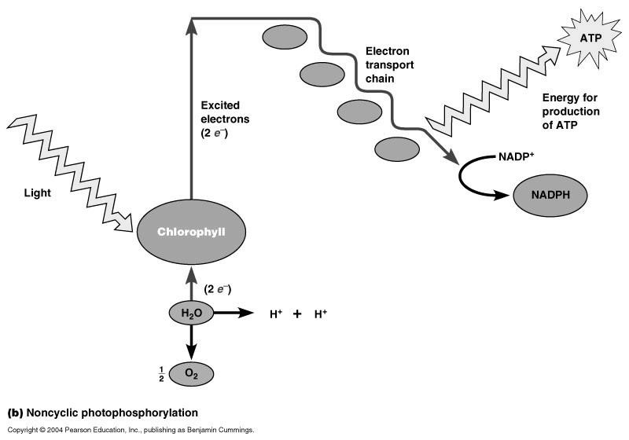

PHOTOSYNTHESIS CONCEPTS

60

LAB 6
The Hill Reaction
Laboratory Procedure

Introduction:
Photosynthetic organisms are capable of capturing light energy and using it to form sugars and oxygen gas. This is an amazing ability!
Today you will isolate chloroplast organelles from spinach leaves. Chloroplasts can be isolated from the rest of the cell components using centrifugation, based on the weight of chloroplasts. After isolation, you will test the ability of the Chloroplasts to oxidize water (the first step of Photosynthesis in plants) by performing an assay called the Hill Reaction. During the first step (Light-dependent reaction) of Photosynthesis, plants oxidize water to provide an electron for the chlorophyll pigment. In the Hill Reaction, an artificial electron acceptor (2,6 dichlorophenolindophenol or DCIP) is used to intercept the electron. When DCIP is reduced, it loses its blue color.

H₂O + DCIP (oxidized) → DCIP⁻ (reduced) + ½ O₂
BLUE COLOR COLORLESS

A change in absorbance is used to measure the rate of the Hill Reaction, or the rate of photosynthesis. When the chloroplasts are exposed to light, DCIP will be reduced and will become colorless.
DCIP will be made to a concentration of 4x10⁻⁴ M. (The molecular weight is 290.08g/mol.) The instructor will prepare 0.012 grams in 100ml of distilled water.

LAB OUTLINE
- Chloroplast Isolation
- Hill Reaction using Isolated Chloroplasts

Practice Questions: Please answer these with your lab group
- The Photosynthesis Reaction: (Fill in the blanks!)
________ + ________ → ________ + ________
- In the Hill Reaction, the color of the solution will change from __________ to __________.
- In the Hill Reaction, the absorbance will ____________ (increase OR decrease).

A. Chloroplast Isolation
- Prepare an ice bath and pre-cool all glassware, and the mortar and pestle.

- Select fresh spinach leaves then remove the large veins in the center of each leaf using a razor. Weigh 6.0 grams of deveined leaf tissue.

- Chop the leaves finely with a razor blade. (You may use a paper towel on your benchtop.)

- Add 15ml of ice-cold Tris-NaCl buffer (made earlier in the semester) to a mortar then add the 6 grams of chopped spinach. Grind to a fine paste. This should take AT LEAST 3 minutes.

- Cut a piece of cheesecloth about 10cm wide then fold the cheesecloth in half. Place it over a cooled beaker then filter the solution squeezing the tissue pulp to recover most of the liquid.

- Transfer 1mL aliquots* of this fluid into 6 labeled eppendorf tubes.
* Aliquot = a portion of the material.
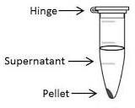
- Place the eppendorfs in the centrifuge.
Balance eppendorfs (opposite sides) with hinges to the outside.
Put the cap on the rotor and close the top.
Centrifuge at 200xg (2,000 rpm) for approximately 1 minute. The pellet is the unbroken cell material and plant cell walls.

- Decant (pour/pipette) the supernatant (liquid) into six clean tubes. Discard pellets (solid).

- Centrifuge at 1000xg (10,000 rpm) for 7 minutes. The pellet formed during this 2nd centrifugation contains chloroplasts.
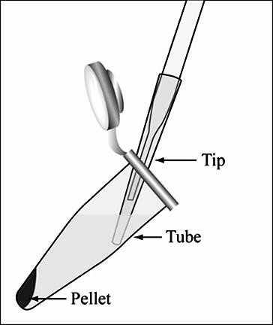
- Decant the supernatants as waste.

- Add 0.75ml of ice-cold Tris-NaCl buffer to each pellet.

- Resuspend (mix) pellet by pipetting up and down.

- Put all 6 pellets together into one glass test tube

- Place chloroplast tube in ice bucket and keep cold
http://ocw.mit.edu/courses/biological-engineering/
B. The Hill Reaction Using Isolated Chloroplasts

Contents of Each Tube:
Cuvette | Tris-NaCl | DCIP | Distilled water
BLANK | 1.75ml | None | 500l
1 - bright light | 1.75ml | 250l | 250l
2- medium light | 1.75ml | 250l | 250l
3 - low light | 1.75ml | 250l | 250l

- Turn on the Computer (back left button) and plug in keyboard and Spectrovis to USB ports (back right). Open LoggerPro.
- Label 4 cuvettes with BLANK, BRIGHT, MEDIUM, and LOW.

- To set up SpectraVis for Hill Reaction:
- Click on Data Collection Button.
Use menu to set type to “Time Based”
Set Duration for 60 seconds;
Do not change Sampling Rate; Set for 10 seconds/sample. Click DONE.

- Click on Configure Spectrophotometer Button.
In Menu, Select 600nm wavelength of light. Click OK.

- Calibrate-
Prepare BLANK cuvette by adding 1.75mL Tris-NaCl and 500l water.
Add 250l of Chloroplast solution to BLANK. MIX! Wipe with Kimwipe.
Place cuvette into SpectraVis with stripes front and back.
In Experiment menu, select “Calibrate”. Click buttons as needed.

- To perform Hill Reaction Assay in Bright Light:
  - Add 1.75ml of Tris-NaCl to the cuvette.
  - Add 250l of DCIP and 250l of distilled water to the cuvette.
  - Wipe with Kimwipe. Place cuvette in SpectraVis.
  - Place the lamp (with LED bulb) directly above cuvette.
  - Mix Chloroplast solution (spinach material) by inverting tube.

  - EVERYONE GET READY - AT THE SAME TIME:
    - Add 250l of Chloroplast solution to cuvette. MIX by squirting quickly..
* Press Triangle button to start recording of data
    - Reposition light to be as close as possible to top of cuvette.
WAIT 60 SECONDS! After the assay is complete:
    - In Experiment menu, select “Store Latest Run” THIS STEP IS NECESSARY!
    - Record data on the data table below.

- To perform Hill Reaction Assay in Medium Light:
  - Repeat Step 4 above with a new cuvette.
  - The only change is Place a plastic weigh boat on top of cuvette during assay to block some light.

- To perform Hill Reaction Assay in Low Light:
  - Repeat Step 4 above with a new cuvette.
  - The only change is Do not use the lamp and cover cuvette in SpectroVis.

DATA TABLE FOR HILL REACTION (A₆₀₀)
Time (seconds) | Bright Light | Medium Light | Low Light
0
10
20
30
40
50
60

- Normalize your raw data by calculating the change in absorbance (A) by subtracting each number from the absorbance of that tube at 0 seconds.

*** The change of absorbance represents the rate of photosynthesis! ****

Rate of Photosynthesis via Hill Reaction in Different Light Intensities (A₆₀₀):
Time (seconds) | Bright Light | Medium Light | Low Light
0
10
20
30
40
50
60

LAB6-Preparation

LAB 6
The Hill Reaction

Preparation for Hill Reaction #2 Lab

** DISCUSS THIS SHEET WITH YOUR PROFESSOR BEFORE YOU LEAVE LAB **

MATERIALS LIST:
- LEAF MATERIAL - Spinach, kale, lettuce, red/purple cabbage, other?
- COLOR OF LIGHT - Lamps, LED light bulbs (white, red, green, blue, yellow)
- TEMPERATURE - Ice, Ice buckets, Heaters, Thermometers
- pH - Buffer, Acid (HCl), Base (NaOH), pH paper
- SALT - NaCl (and other salts)
- LIGHT DISTANCE - Lamps, Meter Ruler
- SOLUTE POLARITY – Soap, Alcohol, etc
- OTHER- Be creative and let me know what materials you need

Instructions:
Next week, you will run your own experiment using the Hill Reaction.
Discuss with your lab group what you would like to test. You only want to change one variable so you can make a reasonable comparison between tubes.

1. What different conditions will your group be testing? ________________________________
_____________________________________________________________________________ 2. HYPOTHESIS: Briefly explain your hypothesis for this experiment. (It’s ok if you end up with results that are the opposite of your hypothesis!) _____________________________________
_____________________________________________________________________________

3. EXPERIMENT: Briefly explain the conditions for each cuvette. You should use a minimum of 4 conditions and a maximum of 6 conditions for your experiment.
Cuvette 1: ______________________________________________________________
Cuvette 2: ______________________________________________________________
Cuvette 3: ______________________________________________________________
Cuvette 4: ______________________________________________________________
Cuvette 5: ______________________________________________________________
Cuvette 6: ______________________________________________________________
*** Recommended- Create a table to record your data and bring to lab next week. *** LAB6-Prelab

PRE-LAB 6
The Hill Reaction

Directions:
TYPE the answers to the following questions and turn in BEFORE lab begins. If pre-lab is not complete at the beginning of lab, the student will be unable to participate in the lab session.

Questions:
- (2pts) While doing this experiment, it will be important to keep everything on ice. Why is it important to keep everything cold? What might happen if the proteins are warmed to room temperature?

- (2pts) While doing this experiment, you will be centrifuging (“spinning”) your samples at
1000xg or 10,000 rpm. What does 1000xg really mean? What does 10,0000rpm really mean? Can you convert xg to rpm? (Is rps ALWAYS 10 times the xg?)

- (2pts) Photosynthesis is a redox reaction. In the light-reaction of photosynthesis, what molecule is oxidized? In the dark-reaction (Calvin Cycle) of photosynthesis, what molecule is reduced? (I’m asking about Photosynthesis, not the Hill Reaction assay.)

- (2pts) In the Hill Reaction (not photosynthesis), what would you expect to happen to absorbance when the test tube is exposed to light? Would it increase, decrease, or stay the same?
Why?

- (2pts) In the Hill Reaction (not photosynthesis), what would you expect to happen to absorbance if the test tube is NOT exposed to light? Would it increase, decrease, or stay the same? Why?

LAB6-Postlab

“Mini” POST-LAB 6
The Hill Reaction

Directions:
TYPE the answers to the following questions and turn in ONE WEEK after lab session. Since you have a formal lab report for this lab, this MINI postlab will only count for 10 points.

Questions:
- (2pts) Explain the purpose of the BLANK cuvette.

- (2pts) Include an Excel table of your Hill Reaction data (just  in Absorbance). Make your table clear and professional with a title of “Table 1:” and a descriptive title.

- (2pts) Include an Excel graph of your data. Your x-axis should be time and your y-axis should be CHANGE in Absorbance (this is the “rate of photosynthesis”). You should have labeled axes and a clear title on your graph. Make sure that your legend is clear. Include a title of “Figure 1:” and a descriptive title.

- (2pts) Compare your data from “BRIGHT”, “MEDIUM”, and “LOW”. Did you see any difference? Why?

- (1pt) Explain why the absorbance changes during the Hill reaction.

- (1pt) Were there any errors in your technique that cause you to be concerned about your data? Explain any potential sources of error.

LAB6-Report
Hill Reaction LAB REPORT:

Description of Laboratory Work:
During this week, you will be working in groups to run Hill Reactions. Each student must write his/her own lab report. In this assignment, the student will demonstrate his/her understanding of the techniques. The student will analyze his/her data to formulate a conclusion. This lab should be based on the 2nd week of Hill Reaction experiments. If you wish, you can use your data from the 1st week, but for most lab groups this is unnecessary.

Due Date: See Syllabus. Late lab reports will have 20% taken off of the grade. Reports more than a week late will receive a zero on the assignment.

Format:
Two to three pages long (not including figures, or coversheet)
Use lab report format (follow instructions on last page of handout closely) Typed double-spaced with reasonable margins
As with any writing assignment, do NOT plagiarize. Use your own words.

Grading:
15 points | Lab Formatting: Report follows correct lab report formatting. (See the attached sheet on lab report format.) All the information is in the correct section. References have been properly cited. Use plagiarism pledge!
15 points | Grammar and Spelling: Spelling is correct throughout report. Grammar is excellent and wording should be clear and concise. Writing style should be scientific not conversational. PROOFREAD!!!
10 points | Title and Abstract: Includes a clear descriptive title. The abstract is an approximately 100 word summary of report. What did you do? Why did you do it? What did you find out from your work?
10 points | Introduction: Section includes the following content:  What is the Hill Reaction? What does it tell us? Include any other background information that is specific to your experiment.
10 points | Methods: Section includes a clear, chronological description of your laboratory work. What did you do to complete this experiment and collect data? Do not include any results or discussion in this section.
10 points | Results: Contains a typed table of your data and a graph (MSExcel) of the data. Each figure should have a number and a title. Results section has a short text stating the results. Do not include any analysis in this section.
20 points | Discussion: Discussion is a clear and correct analysis of your results. What did you learn in your experiment? What do your results show? Do these results make sense with what you understand about Photosynthesis?
10 points | Discussion: Were there any errors made in your technique? How could these be fixed? What further experiments could be done to expand on your results? DON’T FORGET TO WRITE THIS PART!

LAB6-Report

Some Basic Advice on Laboratory Report Formatting

General style:
Strive for logic and precision and avoid ambiguity
Keep your writing formal. Use proper scientific wording.
Use the past tense and be consistent within the report
Italicize all scientific names (genus and species); the first letter of the Genus should be capitalized.
Write numbers as numerals when greater than ten (i.e. 156)
Have a neutral person review and critique your report before submission

Format: The typical lab report includes: title, abstract, introduction, materials and methods, results, discussion, references and literature cited.

Title: Reflect the factual content with less than ten words in a straightforward manner.

Abstract: Summarize in a concise paragraph the purpose of the report, data presented, and major conclusions (such as identity of your two unknowns) in about 100 words.

Introduction:
- Written in paragraph form.
- Define the subject of the report: "Why was this study performed?” - Explain the Hill Reaction and how it relates to Photosynthesis.
- Provide background information SPECIFIC TO YOUR 2nd WEEK HILL REACTION EXPERIMENT.

Materials and Methods:
- Describe chronologically what you did in the lab.
- You do not need to list your materials.
- Provide enough detail for the reader to understand the experiment without overwhelming him/her.

Results:
- Has a brief DESCRIPTIVE TEXT describing your table and graph but with NO ANALYSIS.
- Concentrate on general trends and differences and not on trivial details.
- Summarize the data from the experiments without discussing their implications (conclusions) - Organize data into tables, figures, graphs, photographs, etc.
- Title and number all figures and tables. Graphs should have labeled axes. Tables should be clear.

Discussion:
- Interpret the data; do not restate the results
- Explain the logic that explains why the rate of photosynthesis is higher in certain conditions. Be thorough, do not assume that the reader knows what you mean.
- Relate your comparison of photosynthesis rate to your background information in the Introduction section.
- Speculate as necessary but identify it as such.
- Include suggestions for improving your techniques or design. Discuss any errors.

References & literature cited:
- Alphabetize by last name of the author
- Follow the APA format for citations of references. For APA guidelines see www.library.cornell.edu/newhelp/res_strategy/citing/apa.html#apa

This information was adapted from http://www.studygs.net/labreports.htm; which had been adapted from Biological Investigations, 5th ed. By Warren D. Dolphin 1999, published by McGraw-Hill."

LAB 7 WESTERN BLOT

WESTERN BLOT CONCEPTS

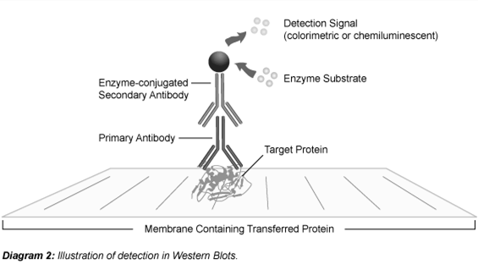

http://www.leinco.com/general_w
b

http://www.leinco.com/general_wb

LAB 7
Western Blot of RuBisCo
Laboratory Procedure

Introduction:
Western blotting is an extremely useful protocol for identifying proteins by their specific interaction with antibodies.
We will begin by isolating Chloroplasts from spinach leaves. Then the Chloroplast proteins will be separated using SDS PAGE.
Next, the proteins are transferred using electrical current onto nitrocellulose (NC) membrane. After the transfer, we will “block” your membrane with blocking buffer to fill in any areas on the NC that are not bound to protein. The NC is then incubated with a specific antibody primary antibody to your protein-of-interest (RuBisCo). Then the NC is incubated with a secondary antibody that sticks to the primary antibody. This secondary antibody is attached to an enzyme Alkaline Phosphatase (AP) that is used to visualize the band by producing a color change when it reacts with its substrate (5-Bromo-4-Chloro-3’-IndolyPhosphate, BCIP and Nitro-Blue Tetrazolium, NBT). The result should be a band where RuBisCo ran on the SDS PAGE.
Ultimately, Western blotting allows scientists to identify a protein-of-interest based on the specificity of the antibody-protein interaction.

LAB OUTLINE:
- Isolation of Chloroplasts
- SDS PAGE Of Chloroplast Extracts
- Transfer to Nitrocellulose
- Western Blot Development for RuBisCo Protein
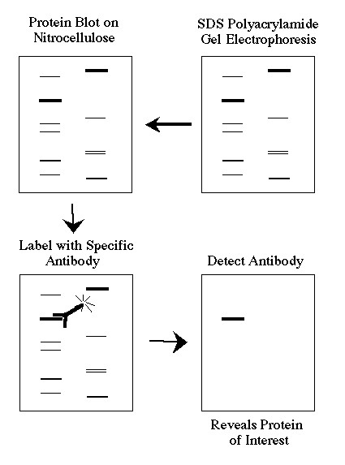

www.bio.davidson.edu/courses/genomics/method/Westernblot.html
A- Isolation of Chloroplasts

Procedure:
- Prepare an ice bath and pre-cool all glassware, and the mortar and pestle.
- Select several fresh leaves, and remove the large veins by ripping out the leaf parts. Discard the large veins. Weigh out 6.0 grams of deveined leaf tissue.
- Chop the leaves finely with a razor blade. Add the tissue to an ice-cold mortar containing 5ml of ice-cold Tris-NaCl buffer and grind to a fine paste. This should take AT LEAST 3 minutes.
- Filter the solution using a double layer of cheesecloth into a cool beaker and squeeze the tissue pulp to recover all of the suspension.

- Transfer 2ml of this fluid into two eppendorf tubes (put 1 ml in each). Label the tubes.

- Balance the tubes by placing them opposite each other, then centrifuge at 200xg (2,000 rpm) for 1 minute to pellet the unbroken cells and cell fragments.
- Pipette the supernatant (liquid) into two clean eppendorf tubes. Centrifuge the supernatants at 1000xg (10,000 rpm) for 7 minutes. The pellet formed during this centrifugation contains chloroplasts. Pipette the supernatant as waste.

- TO ONE TUBE ONLY, add 0.4ml of ice-cold Tris-NaCl buffer. Resuspend by pipetting up and down. DO NOT ADD 0.4mL to the other tube.

- Move the 0.4mL to the next tube and resuspend that pellet. THIS TUBE IS YOUR
CHLOROPLAST SOLUTION.

- Cap the top of the tube and place in ice bucket. Ask the professor to add 10l protease inhibitor to your material. Protease inhibitor blocks proteases (released from the lysosomes) from digesting your cellular proteins.

- In a new eppendorf tube, add 50l of your chloroplast sample and then add 23l of Invitrogen sample buffer.

- Mix well then freeze. THIS TUBE IS THE MATERIAL WE WILL USE FOR SDS PAGE.

B. SDS PAGE Of Chloroplast Extracts using Invitrogen Gel

Procedure:
- Put on gloves. Thaw your chloroplast samples then boil for 2 minutes at 100 degrees C.
- Make 400mL of 1x Running Buffer using 20x stock.

http://www.bio-rad.com/webroot/web/pdf/lsr/literature/Bulletin_1658100.pdf

- Add a small amount of 1x Running buffer to the bottom of the gel box.
- Take gel and remove white tape and comb.
- Place the gel in the chamber with wells facing you.
- Rinse wells 3x with running buffer using disposable pipette
- Add running buffer to front until it fills side chamber.
- Raise gel slightly for easier loading.

- Load the ladder and your samples as shown in table.
LANE | Volume | Material
Lane #1 | --- | BLANK
Lane #2 | 10l | Protein Standard Ladder
Lane #3 | 2l | Chloroplast Extract
Lane #4 | 8l | Chloroplast Extract
Lane #5 | --- | BLANK
Lane #6 | 10l | Protein Standard Ladder
Lane #7 | 10l | Chloroplast Extract
Lane #8 | 20l | Chloroplast Extract
Lane #9 | --- | BLANK
Lane #10 | --- | BLANK

- Carefully open the clamp, lower gel, then close clamp.
- Place the lid on the gel box then connect to power source.
- Run gel at 200V for only 22 min.
- Open gel plastic with tool. Cut gel in half at lane #5 using a razor blade.
- Put Lanes #6 through #10 in Coomassie stain box. We will destain next week.
- Proceed to part C for Lanes #1 through #4.
C. Transfer to Nitrocellulose (NC)

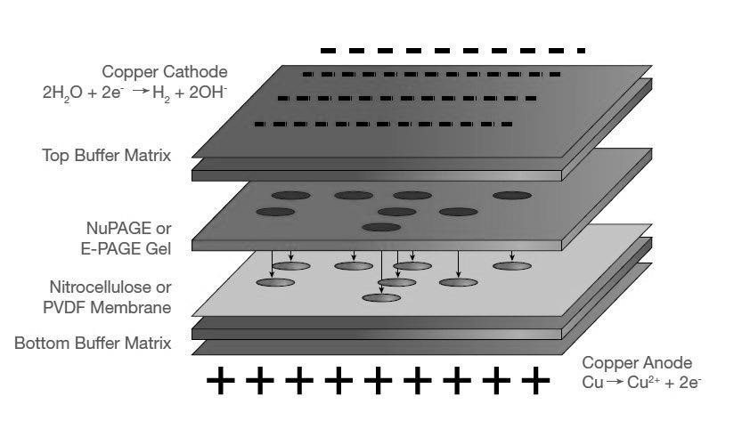

Procedure:
*** TWO LAB GROUPS WILL WORK TOGETHER AND SHARE!!! ***
- Put on gloves. Place one iBlot filter paper in distilled water.
- Open the Transfer Stack. Take top stack (above large paper) and set to side. Discard large paper. Place rest of stack in iBlot machine.
- Place two gels onto top of stack.
- Place presoaked filter paper on top of gel. Roll out bubbles.
- Place the top stack on top. Roll out bubbles.
- Place Absorbent Pad on top with the silver electrical contacts aligned.
- Close lid. Select Method “P0”. Start Run.
- During run, prepare 40mL Blocking Buffer, by adding 5% nonfat dry milk to TTBS.
(TTBS is Tween Tris Buffered Saline, a salt solution with mild detergent.)
- When finished, cut the Nitrocellulose (NC) in half so each group has their own piece.
- Carefully place the NC in 40mL blocking buffer.
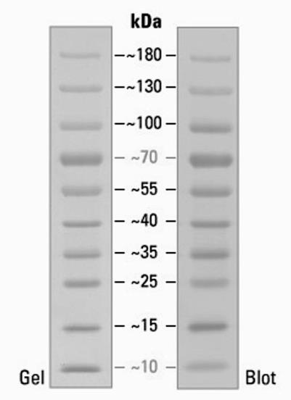
Prestained Protein Ladder:
Note: 70kD band is orange and 10kD band is green

D. Western Blot Development for RuBisCo Protein

Procedure for Primary and Secondary Antibody Incubations:
- Your professor will dilute Primary Antibody (Chicken anti-RuBisCo made by Abcam) 1:2000 in 10ml of blocking buffer.
- Incubate the Nitrocellulose (NC) membrane in Primary Antibody for a few days.
- Your professor will pour the Primary Antibody into a container (to reuse).
- Your professor will wash the NC three times, 5 minutes each time, in 25mL TTBS.
- Your professor will incubate the NC in Secondary Antibody (Goat anti-Chicken antibody made by Abcam) 1:1000 overnight.

Coomassie Stained Gel:
- Pour off Coomassie stain into the designated waste container. Wash gel with water.
- Add Destain solution. Gently rock gel for 30 to 60 minutes.
- If bands are clear, take a picture. If not, destain with fresh Destain solution for another 30 to 60 minutes.

Western Blot:
- You will remove the Secondary Antibody from the Nitrocellulose (NC).
- You will add approximately 25mL TTBS and place the NC on the rocker for 5 minutes.
- Repeat this wash two more times, 5 minutes each time.
- Put on gloves to use the developer solution since it is hazardous.
- Pour a SMALL amount of developer onto NC. Wait until bands appear! Cool!
- Pour developer into waste container. Wash NC with water twice. Take a picture!

Draw a picture of your stained gel and your developed Western Blot. Label the RuBisCo.

DRAWING OF STAINED GEL DRAWING OF WESTERN BLOT



LAB7-Prelab

PRE-LAB 7
Western Blot of RuBisCo

Directions:
TYPE the answers to the following questions and turn in BEFORE lab begins. If pre-lab is not complete at the beginning of lab, the student will be unable to participate in the lab session.

Questions:
- (2pts) The first step of this experiment is to isolate chloroplasts from spinach. Review your
Hill Reaction lab procedure. Briefly explain (2-3 sentences) how you will isolate chloroplasts.

- (2pts) The second step of this experiment is to run SDS PAGE of your chloroplast extracts. Review your SDS PAGE lab procedure. Briefly explain (2-3 sentences) how SDS PAGE will separate proteins based on size.

- (2pts) The final step of this experiment is to do a Western Blot. Explain (2-3 sentences) what happens during a Western Blot procedure.

- (2pts) What is Alkaline Phosphatase and how is it used in a Western Blot procedure?

- (2pts) What will a Western blot tell us about a protein? How is this different from what SDS PAGE will tell us about a protein?

LAB7-Postlab

POST-LAB 7
Western Blot of RuBisCo

Directions:
TYPE the answers to the following questions and turn in ONE WEEK after lab session.

Questions:
- (2pts) Why did we cut the gel in half during our procedure?

- (8pts) Draw (with a pen or pencil) expected results for:
STAINED GEL WESTERN BLOT


- (4pts) We loaded the same material on the two halves of the gel. Why do they look different from each other?

- (2pts) Briefly explain what is happening inside the transfer box during the transfer step.

- (6pts) For the primary antibody:
  - What is the name of our primary antibody in this experiment?
  - How was the primary antibody made (by Abcam)?
  - What happens when we incubate the nitrocellulose in primary antibody?

- (8pts) For the secondary antibody:
  - What is the name of our secondary antibody in this experiment?
  - How was the secondary antibody made (by Abcam)?
  - What happens when we incubate the nitrocellulose in secondary antibody?
  - What is the secondary antibody linked to that allows us to see a band?

LAB7-Postlab
- (2pts) Did the Western Blot visualize any protein bands? (Can you see a RuBisCo band?) Is the result what we expected?

- (4pts) Estimate the size of the RuBisCo protein from your Western Blot.

- (2pts) Is there any background “noise” which gets in the way of seeing the RuBisCo band? Why do Western Blots get background color?

- (2pts) In previous semesters, the RuBisCo band on the Western Blot was found at 5kD instead of 45kD. What might have gone wrong with our procedure?

NCBI
Name: ______________
NCBI and BLAST Exercise:
- Open Safari and go to http://www.ncbi.nlm.nih.gov/
- Use the scroll-down menu to change from “All Databases” to “Protein”.
- Search for “rubisco large subunit spinach”. Check your spelling!
- Look at the list and pick one that does not have the word “partial” in the title.
Look through this page at all the information collected on this protein.
What is the accession number for this protein? ________________________________________
How many amino acids (aa) are in the Rubisco large subunit? ____________________________
What is the genus and species of the spinach organism? ________________________________
Is the gene in the nuclear chromosomes or in the chloroplast (plastid) genome? _______________
What are the first 5 aa in this protein (hint: one letter aa codes)? _________________________ What are the last 5 aa in this protein? ________________________________________________
- Click on “CDS” then “FASTA” in the bottom right side of the page.
What are the first 5 nucleotides of the gene? __________________________________________ (The CDS is the mRNA code but using DNA nucleotides.)
- Now search for “rubisco large subunit spinach”, but change the search menu to PubMed.
What is the date of a recent publication (web or non-web) on Rubisco? ______________________

- Open up a new second window and go to http://www.ncbi.nlm.nih.gov/BLAST/
On the top right, click on the blue box that says “Protein BLAST”
Click on the little box to “Align two or more sequences”.
Enter the accession number from step 4 above into the top box.
- Go back to http://www.ncbi.nlm.nih.gov/ and find the protein for “rubisco large subunit cyanobacteria”.
Hint: Look up the protein sequence. Check that you don’t have a partial sequence.
What is the accession number for this protein? ________________________________________
- Paste or type the accession number into the lower box. Click the button to BLAST then scroll down. There should be three lines of amino acid sequences. The middle line is where the two sequences are the same. Is there homology between the cyanobacterial and spinach rubisco? ________________________ What percent identity do they have? __________________________
77
NCBI
Spinach is a eukaryote and cyanobacteria is a prokaryote. They SHOULDN’T have so much homology!
WHY is there homology between these two proteins? (I’m looking for more than “They have similar ancestors”. The ancestors of prokaryotic and eukaryotic nuclear DNA should not be this similar.)
___________________________________________________________________________________
___________________________________________________________________________________
___________________________________________________________________________________
___________________________________________________________________________________ ___________________________________________________________________________________

78

